**Quiz BF[2] – Enrichment**

Part I – Individual Quiz (Before Class)

Part II – Group Quiz (During Class)

1. What is the notation for the Two-Way BF Design (4 pts)?

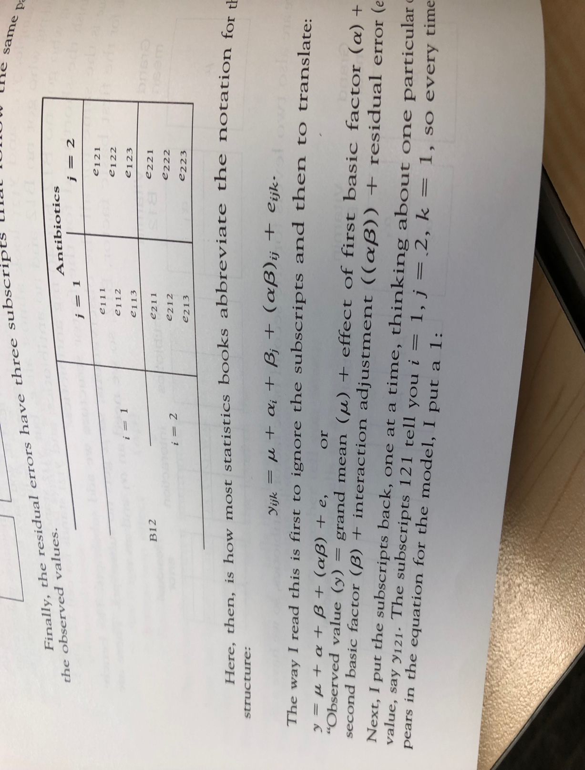

𝑦_𝑖𝑗𝑘=𝜇+𝛼_𝑖+𝛽_𝑗+(𝛼𝛽)_𝑖𝑗+𝜀_𝑖𝑗𝑘

𝑤ℎ𝑒𝑟𝑒 𝑖 𝑖𝑠 𝑡ℎ𝑒 𝑖^𝑡ℎ 𝑙𝑒𝑣𝑒𝑙 𝑜𝑓 𝑓𝑖𝑙𝑙𝑒𝑟 𝑖=1,2

𝑤ℎ𝑒𝑟𝑒 𝑗 𝑖𝑠 𝑡ℎ𝑒 𝑗^𝑡ℎ 𝑙𝑒𝑣𝑒𝑙 𝑜𝑓 𝑝𝑟𝑜𝑝𝑜𝑟𝑡𝑖𝑜𝑛 𝑗=1,2,3

𝑤ℎ𝑒𝑟𝑒 𝑖𝑗 𝑖𝑠 𝑡ℎ𝑒 (𝑖𝑗)^𝑡ℎ 𝑙𝑒𝑣𝑒𝑙 𝑜𝑓 𝑡ℎ𝑒 𝑖𝑛𝑡𝑒𝑟𝑎𝑐𝑡𝑖𝑜𝑛

𝑤ℎ𝑒𝑟𝑒 𝑘 𝑖𝑠 𝑡ℎ𝑒 𝑘^𝑡ℎ 𝑟𝑒𝑝𝑙𝑖𝑐𝑎𝑡𝑒 𝑜𝑓 𝑡ℎ𝑒(𝑖𝑗)^𝑡ℎ 𝑙𝑒𝑣𝑒𝑙 𝑜𝑓 𝑡ℎ𝑒 𝑖𝑛𝑡𝑒𝑟𝑎𝑐𝑡𝑖𝑜𝑛

**End of Part I**

1. Were you in class on time (2 pts)?

Yes

1. Work with Type I and Type III Sum of Squares for the Cancer Data (5 points)

CancerAnova <- anova(lm(age ~ type*gender, data=Cancer))

Df Sum Sq Mean Sq F value Pr(>F)

----------------- ---- -------- --------- --------- --------

**type** 5 399.8 79.96 0.6629 0.6532

**gender** 1 50.88 50.88 0.4218 0.519

**type:gender** 5 584.1 116.8 0.9685 0.4459

**Residuals** 51 6152 120.6

CancerAnovaMix <- anova(lm(age ~ gender*type, data=Cancer))

Df Sum Sq Mean Sq F value Pr(>F)

----------------- ---- -------- --------- --------- --------

**gender** 1 45.83 45.83 0.38 0.5404

**type** 5 404.8 80.97 0.6713 0.647

**gender:type** 5 584.1 116.8 0.9685 0.4459

**Residuals** 51 6152 120.6

CancerAnova1 <- lm(age~gender*type, data=Cancer, contrasts=list(type=contr.sum, gender=contr.sum))

Sum Sq Df F value Pr(>F)

----------------- -------- ---- --------- -----------

**(Intercept)** 181519 1 1505 1.588e-39

**gender** 6.261 1 0.0519 0.8207

**type** 340.1 5 0.5638 0.7272

**gender:type** 584.1 5 0.9685 0.4459

**Residuals** 6152 51